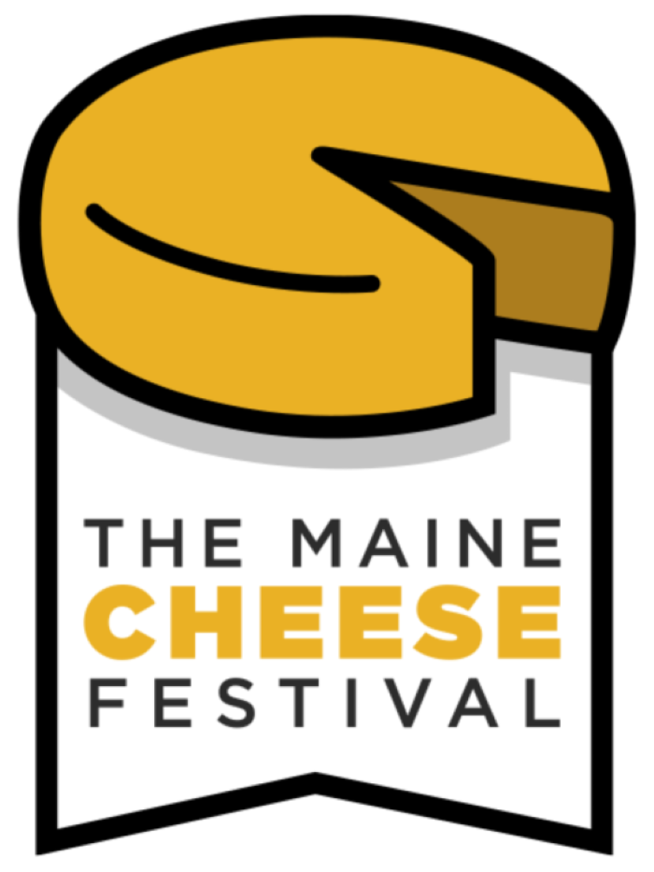

**2024 Maine Cheese Festival Schedule of Events**

**Main Stage: Sponsored By Five County Credit Union** 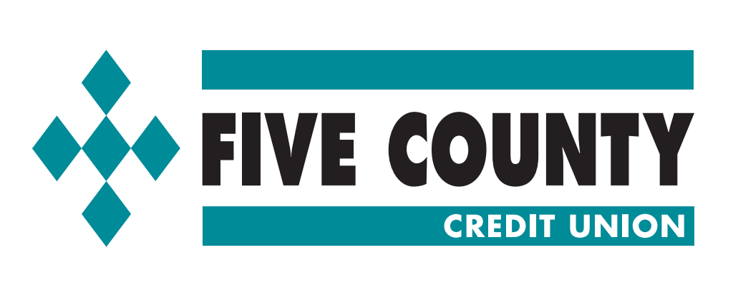

**Music all day!**

**Featuring:**

**11:00 AM - 2:00 PM: Sigrid Sibley Band**

**2:00 PM- 5: 00 PM: Jazmin DeRice Miller & Band**

**Other Main Stage Events:**

**11:15 AM: Welcome by Irene Burgess, Maine Cheese Guild Executive Director**

**4:00 PM: 2004 Maine Cheese Awards Announced!**

**Beer Garden: Acoustic Music**

**11:00 AM-2:00 PM: Lauren Crosby**

**2:00 PM-5:00 PM: Jud Caswell**

**Emcee and Indigenous Music in the Interstices: Scott Edwards**

**3:00 *Crafted Bliss:* A Journey through Cider and Cheese Pairings**

**Join Jon Stein, founder and cider maker at Fogtown Brewing Company, and Kate Turcotte, long-time cheese artisan, to explore the perfect marriage between cider and cheese. Discover new ciders and how they complement various types of cheese–all made here in Maine by local producers. This session offers insights that will elevate your tasting adventures, whether you're a seasoned enthusiast or a curious beginner. Presented by Heart of Ellsworth, organizers of the annual Downeast Cider + Cheese Festival in Downtown Ellsworth, Maine each November.**

**Cheese Fairies!!!!**

**You’ll know them when you see them! Look for the wings!**

**Wandering Wizard Wes!**

**Look for him on the Festival Grounds!**

**Wes Booth will delight you with his magic.**

**Education Tent:**

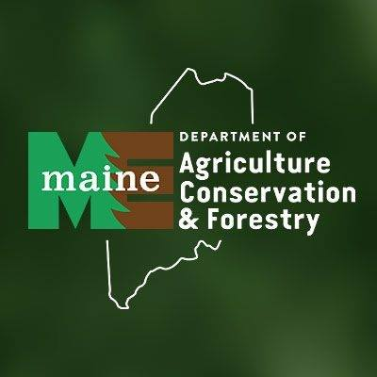

**12:00 Paneer: India’s Cheese Comes to Maine**

**A Demonstration of the paneer cheesemaking process and highlighting the importance of paneer in Indian cuisine. Speakers will be Rob Dumas, University of Maine, Food Science Innovation and Facility Manager; Cherie Scott, Owner and CEO of Mumbai to Maine, and Beth Calder, University of Maine, Extension Food Science Specialist.**

**Rob is a Certified Executive Chef, and through his work, leverages resources of the UMaine system to support economic growth in Maine's food and agricultural sectors. He manages two commercial food facilities at UMaine that support research and education for food producers, faculty and students.**

**Cherie Scott created her own line of Indian simmer sauces from her kitchen in Boothbay, ME to share a part of her cultural heritage with Mainers (and beyond) through her food business, podcasts and other social media channels:**

[**https://mumbaitomaine.com/**](https://mumbaitomaine.com/)**.**

**Beth Calder assists the food industry with food testing, research and educational programs on how to navigate the complex process of starting a food business.**

**2:00 The Science of Cheesemaking**

**How can so many types of Cheese be made from the same four ingredients? Magic!? No, Science! Join us to learn how these cheesemakers use different production methods and aging techniques to create the range of cheeses that we see at the festival today. Kate Turcotte, long time cheesemaker, walks us through this fascinating process that produces so much deliciousness.**

